**Mission Accomplished? A Cross-national Examination of Charity Dissolution**

Diarmuid McDonnell1, Alasdair Rutherford2 and Carolyn Cordery3

*Working Paper 2018-02*

*[NOT FOR CITATION]*

1. Research Fellow. Third Sector Research Center, School of Social Policy, University of Birmingham, UK (d.mcdonnell.1@bham.ac.uk).

2. Professor of Social Statistics. Faculty of Social Sciences, Colin Bell Building, University of Stirling, UK.

3. Professor of Accounting. Department of Accounting, Aston Business School, UK.

**Abstract**

Encouraged by ‘open data’ movements, regulators have made it increasingly straightforward for stakeholders to access large-scale data about charities and their regulation. This research leverages some of these data resources to examine a topic of considerable public and regulatory importance: charity dissolution due to mission accomplishment. The charity sector's claim to exist for the public good is no longer assumed and must be evidenced, however little is known about the extent to which charities accomplish their missions. In this paper we describe continuing work to collect, clean, harmonise and analyse international data on charity dissolution. In doing so we identify real opportunities for interdisciplinary collaboration, combining accounting, social policy, law and data science in order to address important questions in novel ways.

Keywords: charity success, big data, open data, nonprofit dissolution**1.** **Introduction**

Nonprofit and specifically charity regulation is in flux. Stagnant or declining regulator budgets are the new normal and charities themselves are subject to increasing levels of public scrutiny. To meet these and other challenges, many regulators are shifting to an approach informed by risk assessment and analysis (McDonnell & Rutherford, 2019). This requires regulators to leverage their considerable data resources to better target their interventionist and advisory activities, and deliver their mandate. Until recently, relatively little nonprofit regulatory data was shared beyond lists of registered charities. Encouraged by increasing ‘open data’ movements, regulators have made it increasingly easier for stakeholders to access a range of both quantitative and qualitative data about charities and their regulation on a large scale. New nonprofit regulators are being formed, or reformed, and decisions are being taken about what data to collect, and how to use it (Cordery & Deguchi, 2018). This paper describes ongoing work to leverage some of these data resources to examine a topic of considerable public and regulatory importance: charity dissolution due to mission accomplishment. There are many reasons charities shut down (e.g. insufficient funds, non-compliance with legal requirements), but this project will focus on organisations that dissolve after accomplishing their mission. The charity sector's claim to exist for the public good is no longer assumed and must be evidenced (Brody, 2002). However, little is known about the extent to which charities accomplish their missions. Given the increasing scrutiny on charitable organisations in many jurisdictions and the importance of public confidence to their sustainability (Breen, 2009; Keating & Frumkin, 2003), research on this topic has the potential to make a significant contribution to the evidence base on charity success and failure, benefiting a variety of stakeholders including those with responsibility for monitoring the sector (Saxton et al., 2012).

In this paper we report our initial work to collect, clean and analyse large-scale regulatory data to study charity dissolution. We provide a repository of well-documented syntax files that researchers can use to reproduce the work undertaken in this project, and to generate their own datasets for analysis. The paper proceeds as follows. The next section reviews scholarship on charity success and failure, revealing the empirical gap in our understanding of mission accomplishment. Next we describe the methodology underpinning the research, in particular focusing on the key issues of defining and measuring the dependent variable, and the data collection process. We present some preliminary findings, and reflect on the advantages and disadvantages of employing large-scale regulatory data to study this outcome. We conclude by outlining our plans for developing this research.

**Literature**

**Theoretical perspectives**

Defining charity success and/or failure has proved problematic (Lecy et al., 2011). There are various conceptualisations of failure including resource reduction, market exit, and mortality (Helmig et al., 2014; (Mellahi & Wilkinson, 2004). However, many of these constructs contain inconsistencies and contradictions. For example, organisational dissolution may indicate success rather than failure in cases where the charity accomplished its mission (Helmig et al., 2014; see also Hager, Galaskiewicz, Bielefeld & Pins, 1996). On the other hand, charity success is easier to conceptualise but poorly understood for a number of reasons (Helmig et al., 2014). Extant studies have focused on a limited number of subsectors such as Social Service organisations (Helmig et al., 2014); used observations from small regional study sites (e.g. Wollebaek, 2010); and covered short time periods (e.g. Hager et al., 1996). The most difficult issue has been to unambiguously measure mission accomplishment - those charities that voluntarily cease to exist due to achieving their stated mission - and differentiate it from other forms of dissolution such as organisational wind-up, statutory revocation of charity status due to misconduct, and other forms of ‘mortality’ e.g. amalgamation.

**Empirical evidence**

By using detailed measures of charity dissolution recorded in large-scale regulatory datasets, this research project responds to the call for greater focus on mission accomplishment as an outcome in nonprofit scholarship (Helmig et al., 2014). Our work has the potential to provide much-needed granularity and clarity to the various ways charities cease their activities, in particular by identifying those organisations that dissolve as a result of accomplishing their mission. Identifying the patterns and explanatory factors associated with charity dissolution can underpin public understanding of the sector, inform the allocation of funds by donors and government, and guide the activities and interventions of regulators.

[Specify a theoretical model using the three theories and previous empirical work.]

**New Zealand**

The charity regulator in New Zealand began in mid-2007, having been established under the Charities Act 2005. While it began as an Autonomous Crown Entity, since 2012, it has been situated within a large government department (Cordery and Deguchi, 2018). Charities have always been required to report annually to retain their registration and this includes details of the sector, main beneficiaries, updated officer/trustees and financial reporting. No specific financial accounting standards had been developed and therefore charity reporting was previously highly diverse. From 2009-2011, accounting requirements for the public and private not-for-public sectors were overhauled owing to a need for a more strategic approach to reporting and the new arrangements included a full set of standards for the charity sector (with increasing levels of measurement and disclosure based on four different tiers related to annual expenditure) and these new charity accounting standards were mandatory for all charities from 2016. Charities with expenditure over NZD1 million must have these statements audited (Crawford, Morgan, Cordery, & Breen, 2014). (this could be a footnote and/or include exchange rates to other currencies)

Crawford, L., Morgan, G. G., Cordery, C. J., & Breen, O. B. (2014). International financial reporting for the not-for-profit sector: a study commissioned by the CCAB. London, UK.

For charities with expenditure of less than NZD2 million, in addition to finanical data, they must also provide performance information about the difference they make by operating, i.e. how they have achieved (or otherwise) their mission. Such reporting will also be reuqired of larger charities from 2021 (McConville and Cordery, 2018)

**Methodology**

The research objectives are: to explore the extent to which large-scale regulatory data can be used to differentiate between different types of charity dissolution; to examine cross-national trends and predictive factors around charity dissolution; and to provide evidence and guidance for charity regulators seeking to target their activities with respect to this outcome. The project is guided by two research questions:

1. What is the rate of charity dissolution, and does it vary across jurisdictions?
2. What factors predict mission accomplishment, and do they vary across other forms of charity dissolution?

While the wider project incorporates data from multiple jurisdictions, in this paper we focus on New Zealand. This jurisdiction is of interest for a number of reasons: the extant literature is US-centric and New Zealand represents an interesting new field of study for this topic (the regulator was established in 2007); the data are publicly available; and a synoptic review of the data suggested that dissolution could be measured in a granular manner.

**Data**

To answer the research questions we construct a cross-sectional data set of registered charities by downloading and linking multiple regulatory data files (see the technical notes in Appendix A for details of this process). First, our primary data source is the register of charities, a census of all organisations that have at some point been registered with the New Zealand regulator as of 20th of August, 2019 (c. 37,000). This file contains core information such as charity name and registration number, registration status, organisational type, street address etc (though no financial information beyond annual return due dates). Second, we link information on a charity’s main sector, source of funds and activities, as well as areas of operation and number of trustees (which all exist as separate data files). Third, we construct a panel data set of annual returns filed by a subset of these charities (c. 32,000 submitting c. 190,000 returns over the period 2007-2019) and operationalise a number of measures of interest (e.g. average annual gross income), which are then linked to the primary data source via a charity’ unique registration number. Finally we obtain economic and demographic information of the areas in which the charities operate from [StatsNZ].

**Sample Building**

Our initial data, drawn from the register of charities, comprised of 37,903 observations for the same number of organisations. For data cleaning, we first excluded charities for which we could not identify dissolution type. Second, we drop observations for charities that never filed an annual return with the regulator; while this results in a moderate drop in sample size (c. 5,000 organisations), it is necessary as many of the independent variables are derived from annual return data. Finally, we drop observations for which there is missing or clearly erroneous data for the independent variables (e.g. negative annual gross income). The final sample is composed on *n* observations for the same number of charities – see table # in the appendices for full details of the sample building process.

**Variables**

*Dependent variable*

Many nonprofit regulators have a mandate to construct and maintain an accurate, complete and public register of organisations that currently possess charity status. In addition these regulators will retain, though sometimes not share, the list of organisations no longer registered as charities. There is considerable variation across jurisdictions in how charity deregistration is recorded: some regulators do not disaggregate between the different forms (e.g. Scotland, Republic of Ireland, Northern Ireland), while others differentiate at least to some degree (e.g. England & Wales, Canada, New Zealand, Australia).

For New Zealand, we consider a charity to be dissolved if it is no longer listed as registered with the regulator: this includes organisations that continue to exist but voluntarily revoked their charity status, charities that have had their status removed for non-compliance with regulatory requirements, organisations that have merged or amalgamated with other charities etc. Therefore, we specify two dependent variables for New Zealand. The first is a binary measure of whether a charity is no longer registered with the regulator; this is defined as a charity whose status is recorded as ‘Deregistered’ on the public register of charities. The second is a multinomial measure of dissolution, where we disaggregate the group of deregistered charities by reason for dissolution. To differentiate based on dissolution reason, we use regular expressions to extract the section of the Act a charity was deregistered under from the relevant field in the data file. For example, “This entity was removed from the Charities Register under section 32(1)(b) of the Charities Act because it failed to file Annual Returns as required by section 41 of the Charities Act.” is coded as “Failed to file”. Table # below describes our two dependent variables.

**Table 1.** Dependent Variables - Operationalisation

|  |  |  |
| --- | --- | --- |
| Concept | Variable | Operationalisation |
| Dissolution | `deregistered` | Binary measure of the current status of a charity:  0 = Registered  1 = Deregistered |
|  |  |  |
| Dissolution type | `orgdiss` | Multinomial measure of a charity’s dissolution type:  0 = Registered  1 = Failed to file  2 = Voluntary removal  3 = Wound up |

Note: there are other types of dissolution (e.g. mergers) that occur infrequently and thus are recoded as missing data for the purposes of statistical modelling.

*Independent variables*

The first set of independent variables are drawn from population ecology theory and measure an organisation’s capacity and niche operating environment. *Size* is a log transformation of a charity’s mean annual gross income. *Age* is the number of years a charity has been registered with the regulator (we are unable to tell when an organisation was founded). *Type* is a categorical measure of a charity’s regulatory form: “standard”, “society or institution”, and “trustees of a trust” are the three valid values for this variable. Charities are not required to take any form of incorporation; those that do may be established as a Charitable Trust (registered under the Charitable Trusts Act 1956 either as an unincorporated charitable trust or incorporated as a Charitable Trust Board about 60%), Incorporated Society (registered under the Incorporated Societies’ Act 1908 – about 31%), a Limited Liability Company (registered under the Companies Act 2013 or its precursors about 1%), or by a specific Act of Parliament (about ? %). [Diarmuid are you able to provide up to date percentages or do you want me to use those I have from about three years ago?] The incorporated bodies enjoy limited liability, with incorporated societies being required to have minimum membership before incorporation, while trustees of unincorporated trusts are personally liable for any debts or contracts that such bodies could enter into (Crawford et al., 2014).

**Empirical Model**

We are interested not only in whether a charity experience dissolution, but which type of dissolution occurred. We draw on two core theories – population ecology and resource dependence – as well as prior empirical work to develop our theoretical framework. [MATERIAL ON WHY THESE TWO THEORIES AND NOT OTHERS] We use this framework to operationalise eleven explanatory variables – see table # for how these variables map to the theoretical framework. As our first dependent variable - whether a charity has dissolved or not - has two mutually exclusive and exhaustive outcomes, we specify a logistic regression model. Our second dependent variable – dissolution type – has multiple exclusive and exhaustive outcomes and thus we specify a multinomial logistic regression. [MATERIAL ABOUT THESE APPROACHES AND HOW WE REPORT RESULTS]. We model both dependent variables as the probability of a charity experiencing a given outcome as a function of organisational size, age, and type, main economic sector, main beneficiary group served, geographic scale of operations, whether it derives a majority of its income from private donations, whether government is its main source of revenue, average number of employees and volunteers, and total number of trustees.

**Results**

**Descriptive Statistics**

**Figure 1.** Cumulative Number of Dissolutions, By Year and Type

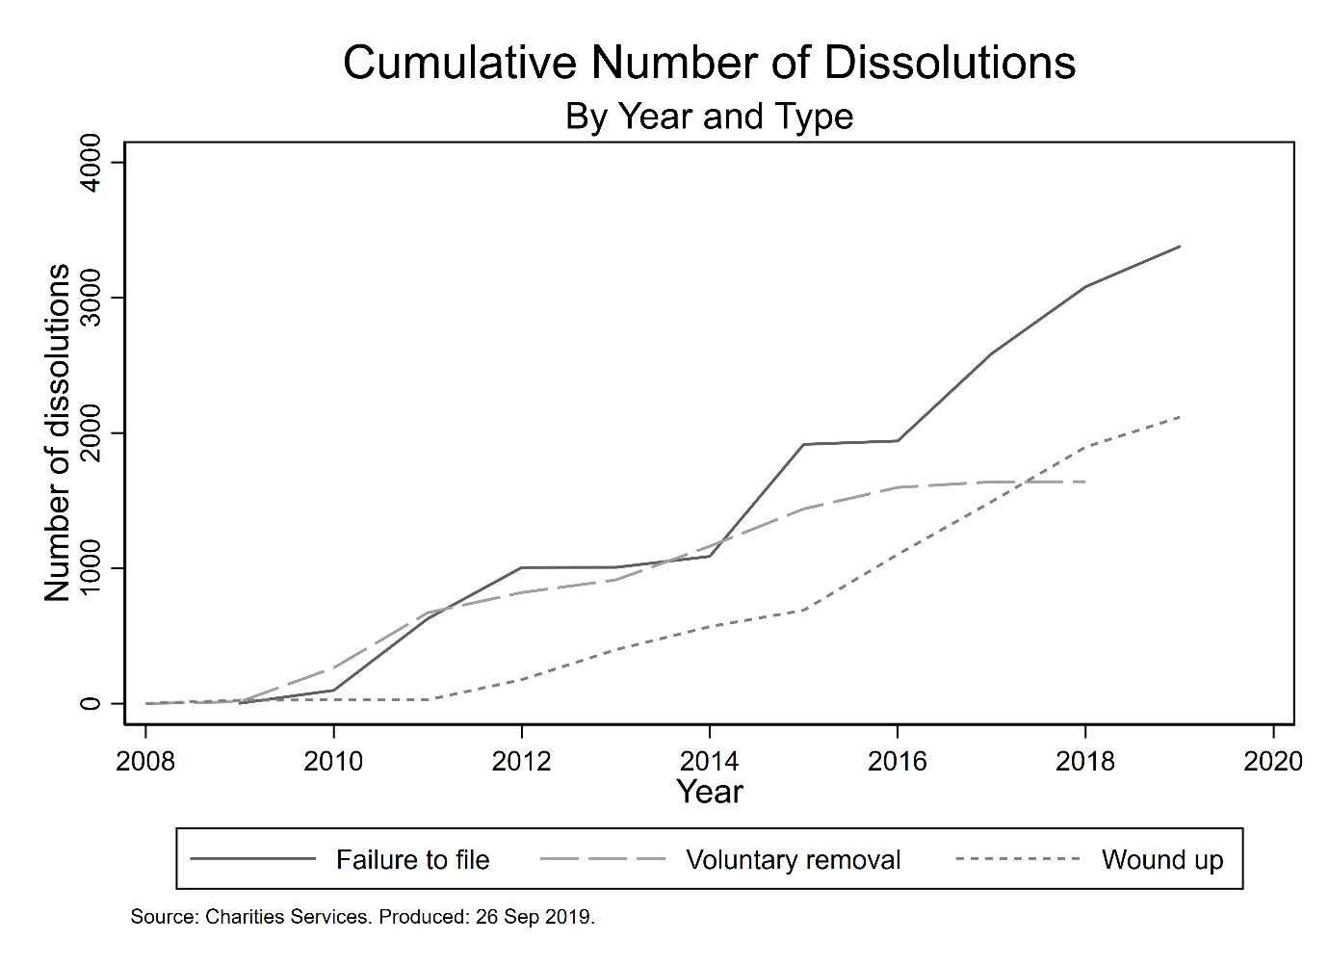

**Statistical Modelling**

Before discussing the results of the regression analyses, Table # contains descriptive statistics for the independent variables included in the models. [DESCRIBE SUMMARY STATS] The presence of multicollinearity among the independent variables in the model was examined by calculating the variance inflation factors (VIF): mean VIF is 1.14 and no variable has a VIF greater than 1.23, below the threshold at which Allison (1999) suggests multicollinearity is problematic. We report log odds, robust standard errors, confidence intervals and a range of model fit statistics (see Connolly, Gayle & Lambert, 2016).

Table # below reports the results of the logistic regression on whether a charity is dissolved or not. We focus first on our population ecology variables. An increase in organisation size is associated with a decrease in the odds of dissolution, while an increase in age is correlated with an increase in the odds. Compared to standard charities, both other organisational types have higher odds of experiencing dissolution. Both resource dependence measures are statistically significant: having government as a main source of revenue is associated with higher odds of experiencing dissolution, while deriving a majority of income from donations is correlated with lower odds. Finally, the control variables are not associated with the outcome, with the exception of total number of trustees, where there is some evidence that larger boards decreases the odds of becoming dissolved.

**Table #.** Results of Logistic Regression on Outcome of Dissolution

|  |  |  |  |  |  |
| --- | --- | --- | --- | --- | --- |
|  |  |  |  | 95% CI | |
|  |  | Log odds | SE | Lower | Upper |
| *Population Ecology* |  |  |  |  |  |
| Size |  | -0.17*** | 0.01 | -0.19 | -0.15 |
| Age |  | 0.06*** | 0.01 | 0.05 | 0.08 |
| Type |  |  |  |  |  |
|  | Standard charity | Ref. | – | – | – |
|  | Society or institution | 5.02*** | 0.08 | 4.87 | 5.17 |
|  | Trustees of a trust | 5.26*** | 0.08 | 5.10 | 5.42 |
| Education |  | -0.19** | 0.07 | -0.33 | -0.06 |
| CYP |  | 0.07 | 0.06 | -0.06 | 0.19 |
| Area of Operation |  |  |  |  |  |
|  | Local | Ref. | – | – | – |
|  | National | 0.07 | 0.06 | -0.04 | 0.18 |
|  | International | -0.01 | 0.10 | -0.21 | 0.20 |
| *Resource Dependence* |  |  |  |  |  |
| Donations |  | -0.23*** | 0.06 | -0.34 | -0.12 |
| Government |  | 0.37*** | 0.05 | 0.27 | 0.47 |
| *Controls* |  |  |  |  |  |
| Employees |  | 0.00* | 0.00 | 0.00 | 0.00 |
| Volunteers |  | 0.00 | 0.00 | 0.00 | 0.00 |
| Trustees |  | -0.05*** | 0.00 | -0.06 | -0.05 |
| *n* |  | 30,656 | |  |  |
| McFadden’s adjusted R2 |  | 0.56 | |  |  |
| McKelvey and Zavoina’s R2 |  | 0.60 | |  |  |
| Cragg and Uhler’s R2 |  | 0.67 | |  |  |
| BIC full model |  | 14,536.67 | |  |  |

Note: Figures rounded to two decimal places. Constant is omitted. CYP: Children and Young People. SE: robust standard errors; CI: confidence interval; Ref.: reference category; BIC: Bayesian Information Criterion. The organisation type variable is statistically significant overall. *p < .05. **p < .01. ***p < .001.

We now consider our multinomial model of dissolution, where we are interested in whether the effects identified above vary significantly by type of dissolution.

**Figure 2.** Regression Coefficients of Independent Variables, By Dissolution Type

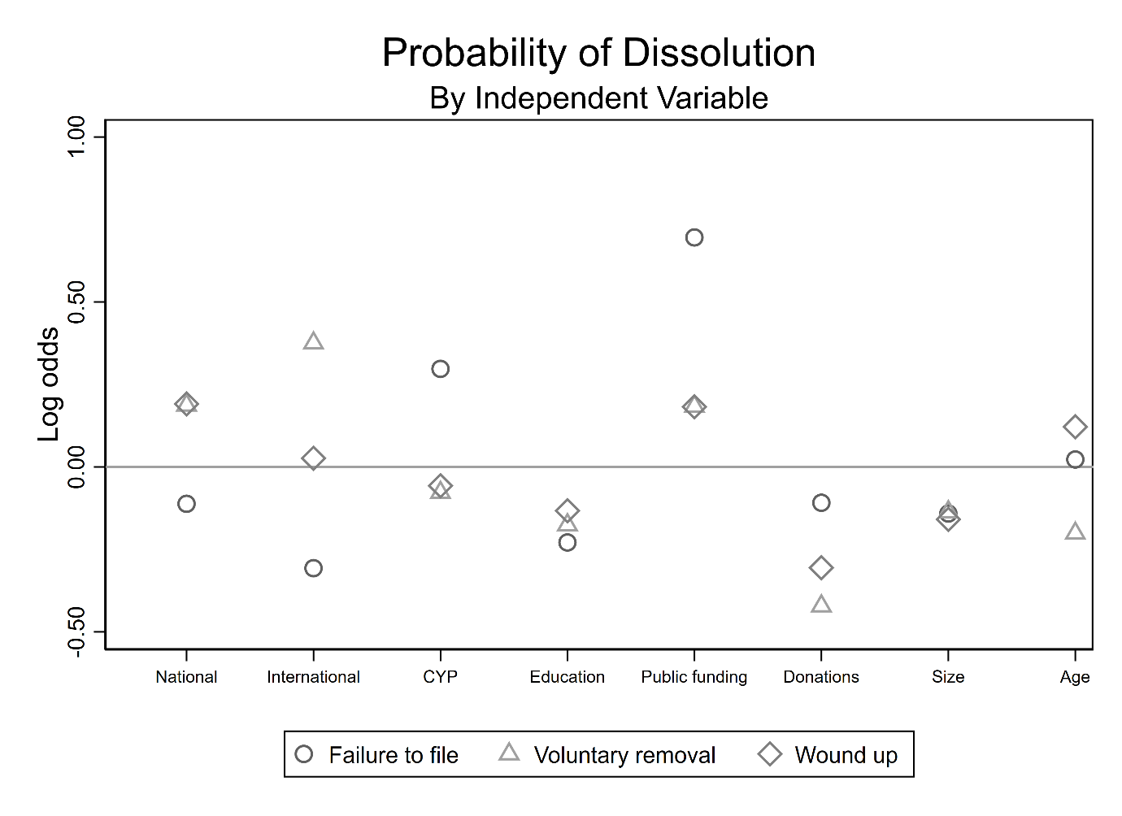

**Table #.** Results of Multinomial Regression on Outcome of Dissolution Type

|  |  |  |  |  |  |  |  |  |  |
| --- | --- | --- | --- | --- | --- | --- | --- | --- | --- |
|  |  | Failed to file | |  | Voluntary removal | |  | Wound up | |
|  |  | Log odds | SE |  | Log odds | SE |  | Log odds | SE |
| *Population Ecology* |  |  |  |  |  |  |  |  |  |
| Size |  | -0.14*** | 0.01 |  | -0.14*** | 0.02 |  | -0.16*** | 0.01 |
| Age |  | 0.02* | 0.01 |  | -0.20*** | 0.02 |  | 0.12*** | 0.01 |
| Type |  |  |  |  |  |  |  |  |  |
|  | Standard charity | Ref. | – |  | Ref. | – |  | Ref. | – |
|  | Society or institution | 4.56*** | 0.08 |  | 7.31*** | 0.24 |  | 4.18*** | 0.09 |
|  | Trustees of a trust | 4.77*** | 0.08 |  | 7.43*** | 0.24 |  | 4.75*** | 0.09 |
| Education |  | -0.23** | 0.08 |  | -0.18 | 0.10 |  | 0.13 | 0.08 |
| CYP |  | 0.30*** | 0.07 |  | -0.08 | 0.10 |  | 0.06 | 0.08 |
| Area of Operation |  |  |  |  |  |  |  |  |  |
|  | Local | Ref. | – |  | Ref. | – |  | Ref. | – |
|  | National | -0.11 | 0.07 |  | 0.19* | 0.09 |  | 0.19** | 0.07 |
|  | International | -0.31* | 0.13 |  | 0.38* | 0.15 |  | 0.03 | 0.14 |
| *Resource Dependence* |  |  |  |  |  |  |  |  |  |
| Donations |  | -0.11 | 0.07 |  | -0.42*** | 0.10 |  | 0.31*** | 0.07 |
| Government |  | 0.70*** | 0.06 |  | 0.18* | 0.08 |  | 0.18** | 0.06 |
| *Controls* |  |  |  |  |  |  |  |  |  |
| Employees |  | -0.01 | 0.01 |  | 0.00*** | 0.00 |  | 0.00 | 0.00 |
| Volunteers |  | 0.00 | 0.00 |  | 0.00 | 0.00 |  | 0.00 | 0.00 |
| Trustees |  | -0.07*** | 0.00 |  | -0.07*** | 0.01 |  | 0.08*** | 0.01 |
| *n* |  | 30,355 | | | | | | | |
| McFadden’s adjusted R2 |  | 0.42 | | | | | | | |
| Cox-Snell R2 |  | 0.46 | | | | | | | |
| Cragg and Uhler’s R2 |  | 0.60 | | | | | | | |
| BIC full model |  | 26320.26 | | | | | | | |

Note: [Explain each of the variables.] [Style this on CITM and density papers] Figures rounded to two decimal places. Constant is omitted. SE: robust standard errors; CI: confidence interval; Ref.: reference category; BIC: Information Criterion. The organisation type and area of operation variables are statistically significant overall. *p < .05. **p < .01. ***p < .001.

**5. Discussion**

Limitations: unidimensional definition of mission completion. Fernandez (2008): “Moreover, the analysis of the dissolution notifications and the in-depth interviews indicated that a small majority of the associations were closed because of one dominating reason.” I.e. plenty closed due to a combination of reasons.

**6. Conclusion**

This paper summarises emerging work on leveraging large-scale regulatory data to answer important research questions in the field of nonprofit studies. The universe of open data is expanding rapidly, offering scholars the opportunity to study key issues in a comprehensive, granular and cross-national manner. However, these datasets have been underemployed in scholarship and research, one of the main reasons for which is the need for intermediate programming and data analysis skills in order to work productively with the data. The impetus behind this research project, outwith the substantive validity of the topic and research questions, is to address some of these barriers by providing reproducible, well-documented syntax files that enable other researchers to generate their own datasets for analysis.

**Appendices**

**Appendix A**

Charities Services maintains an Application Programming Interface (API) that allows programmatic access to the register of charities and a host of other data sets.[1] The service is intended for use by software developers looking to create applications based on regulatory data; however, we have found the basic and advanced search functions the regulator provides through its website unreliable (e.g. search requests often time-out) and time consuming. The open data service is housed in a Microsoft stack that is accessed via the OData Protocol, and users can write code in multiple languages to interact with the Protocol (e.g. Python, PHP, Java). Charities Services OData end point can be reached at <http://www.odata.charities.govt.nz> and there is no authentication required in order to interact with this end point as it is read only (i.e. users cannot alter the data available via the end point). The Data Dictionary lists 13 datasets that can be accessed via the Open Data web service – see Table A3 in the appendices to understand the contents of each dataset.[2] The datasets can be retrieved in any of three formats: ATOM, JSON and CSV.

**Table A#.** Charities Services Open Data

|  |  |  |
| --- | --- | --- |
| File | Type | Description |
| Activities | Reference list | Lookup file of codes used to identify the activities a charity undertakes. |
| AnnualReturns | Dataset | Contains one record for every annual return filed by a charity. |
| AreaOfOperations | Reference list | Lookup reference for codes used to identify the geographical areas a charity operates in. |
| Beneficiaries | Reference list | Lookup file of codes used to identify a charity’s beneficiaries. |
| Groups | Dataset | Contains one record for every charity allowed to file group annual returns. |
| GrpOrgAllReturns | Dataset | Contains one record for every annual return filed by a charity. |
| GrpOrgLatestReturns | Dataset | Contains one record for the most recent annual return filed by a charity. |
| Officers | Dataset | Contains one record for every person that has been a trustee of a charity. |
| Organisations | Dataset | Contains one record for every charity, registered and deregistered. |
| Sectors | Reference list | Lookup file of codes used to identify the sector in which a charity operates. |
| SourceOfFunds | Reference list | Lookup file of codes used to identify a charity’s source(s) of funds. |
| vOfficerOrganisations | Dataset | Contains one record for every person that has been a trustee of a charity, linked to that charity’s organisational information. |
| vOrganisations | Dataset | Contains one record for every charity, linked to the information contained in the Activities, Beneficiaries and Sectors reference lists. |

Note: Charities Services does not provide a description of what each file contains, therefore the content of the *Description* field is our own judgement. As a result we are still unsure how to accurately define the contents of some of the files; we plan on contacting the regulator to get further information.  
Source: <https://www.charities.govt.nz/assets/Resouces/data-dictionary.csv>

**Appendix B**

Table #. Comparison of Dissolution Type, By Initial and Final Sample

|  |  |  |
| --- | --- | --- |
| Dependent Variable | Initial Sample | Final Sample |
| *Dissolution Type* |  |  |
| Registered | 27,130 | 24,663 |
| Failed to file | 5,484 | 3,378 |
| Voluntary removal | 2,064 | 1,640 |
| Wound up | 2,346 | 2,117 |
| *N* | 37,024 | 31,798 |

1. An API is a form of online database that users can query and access data from using http requests.
2.